Create python flask app
Create 3 files
app.py – with python script
requirements.txt – ‘flask’
Dockerfile – with python script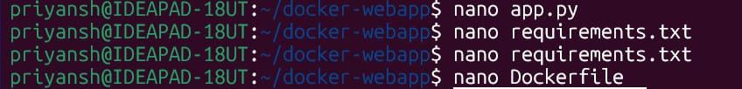
app.py - script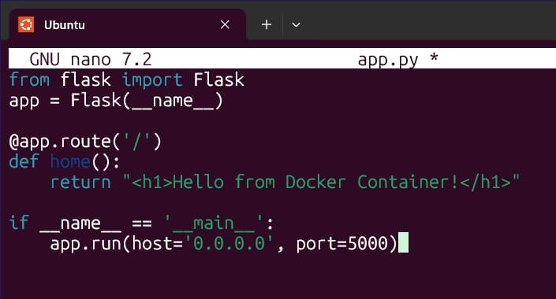
requirements.txt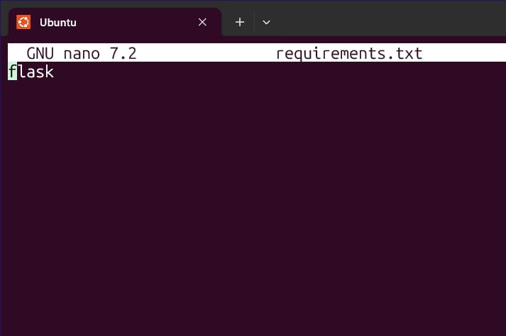
Dockerfile - script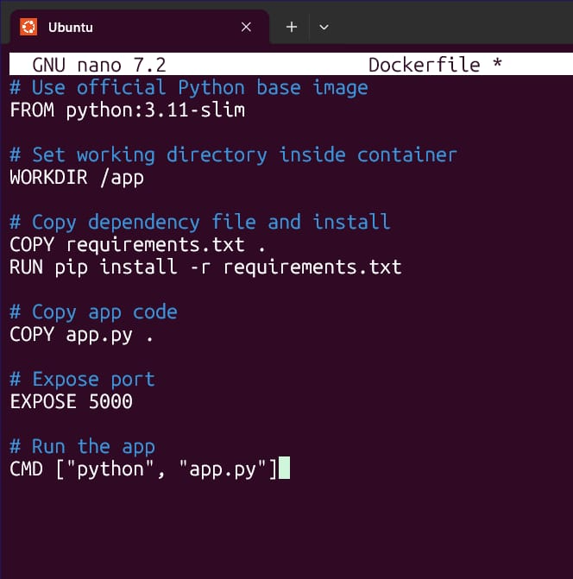
Build, test and run the container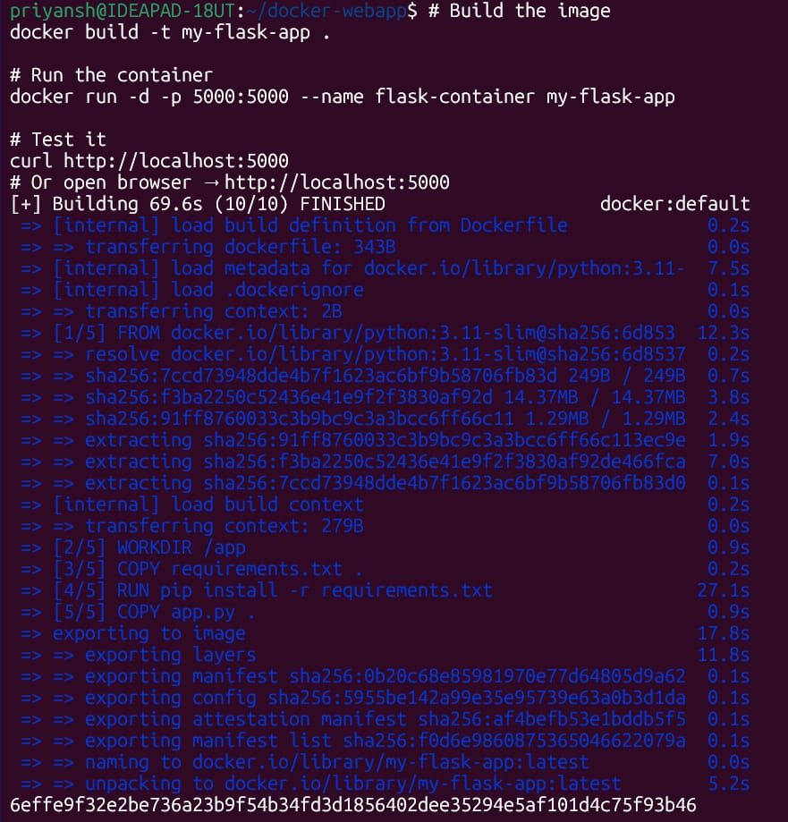
Check logs and then stop container